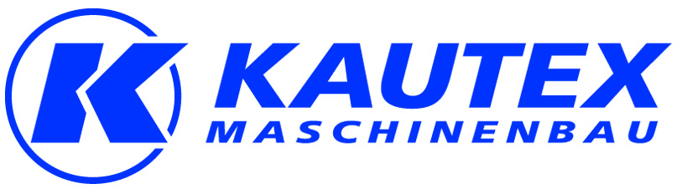

Press Release
Trade Press

31st January 2013
New investors at Kautex Maschinenbau
capiton buys shares in the thriving Kautex Group
Bonn/Berlin - capiton AG is the latest shareholder in the Kautex Group. With this new shareholding, the Berlin-based investors are taking over from former shareholders Steadfast Capital. In March 2007 Steadfast Capital joined together with five members of the management team to buy out 100 percent of the shares held by the Munich-based investment firm Adcuram AG. The latest change of shareholders was approved by Germany's Federal Cartel Authority on 18 January 2013.
Management team now majority shareholders
The Kautex Group is the world's leading manufacturer of extrusion blow molding machinery for the production of plastic containers. "Over the last six years, our close working relationship with Steadfast Capital has helped us to increase the Kautex Group's sales by 75%, despite the slump in demand experienced in 2008 and 2009. We have invested in design and development, sales and customer service, and we are particularly proud of our new Technikum, which we opened in 2012", says Dr. Olaf Weiland, CEO of Kautex Maschinenbau. With this latest change in investors, the management has increased its equity share to 50.1 percent and now holds the majority share in the Kautex Group. The transaction was financed by the capiton IV fund and bank loans. "capiton is a trusted and experienced investor that is totally committed to our values. As a result, we now have the best possible conditions for continuing to develop and strengthen our business activities and the Kautex brand", adds Weiland.
Steady growth
Since leaving the SIG Group in 2004, Kautex Maschinenbau has grown steadily to become the international market leader, with sales in excess of €100 million. Kautex Maschinenbau is at home in every area of extrusion blow molding technology, including automotive applications (such as fuel tanks), packaging and other specialized fields. And the company is expecting above-average growth in the future because blow-molding technology is gaining ground in many other industries. Kautex Maschinenbau is perfectly placed to handle this increased demand from its production plants in Germany and China and its global sales and service network.
(Underline:)
Involved with Kautex Maschinenbau since many years (f.l.t.r.):
Andreas Lichtenauer (Sales), Olaf Weiland (Engineering), Frank Röhrlein (Finances)
(1.896 characters including spaces)

© Kautex Maschinenbau GmbH 2013- Copy permitted, please submit 2 print copies

Reprint free, two voucher copies requested

Contact concerning the press release (e.g. to be printed under the article)

Kautex Maschinenbau GmbH
Kautexstr. 54
53229 Bonn
Tel.: +49 (0) 228 489 0
Fax: +49 (0) 228 489 414
info@kautex-group.com

Editorial contact 

polymediaconsult
Dr. Michael Thielen
Dammer Str. 112
41066 Mönchengladbach
Tel.: +49 (0) 2161 664864
Fax: +49 (0) 2161 631045
mt@polymediaconsult.de

